Early Years Reading Spine 2025-2026
Autumn 1
Term |  | Week 1 | Week 2 | Week 3 | Week 4 | Week 5 | Week 6 | Week 7 | Week 8
Autumn  1  All About Me | Topic Focus | All About me |  |  |  | Autumn |  |  | Festivals / Celebrations
Autumn  1  All About Me | F1 Core Text | 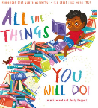  All the things you will do by Lucy Rowland |  | 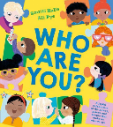  Who are you? By Smriti Halls & Ali Pye |  | 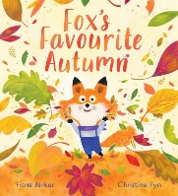  Fox’s Favourite Autumn by Fiona Barker |  |  | 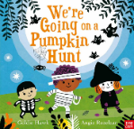  We’re going on a pumpkin hunt by Goldie Hawk    The best Diwali ever by Sonali Shah
Autumn  1  All About Me | F1 Talk Through Stories | Settling period |  |  |  | 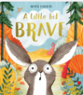  A little bit brave by Nicola Kinnear
Autumn  1  All About Me | F2 Core Text | 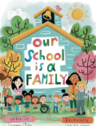  Our school is a family By Shannon Olson |  | 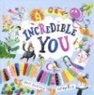  Incredible You by Nathan Reed& Rhys Brisenden |  | 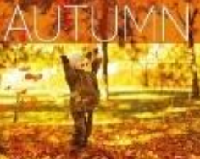  Autumn (non-fiction)
Autumn  1  All About Me | F2 Talk through Stories | Settling period |  | 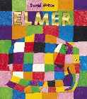  (if settled)  Elmer by David McKee |  | 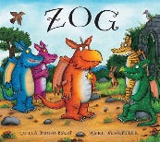  Zog by Julia Donaldson |  | 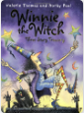  Winnie the witch by Valerie Thomas and Korky Paul

Autumn 2
 |  | Week 1 | Week 2 | Week 3 | Week 4 | Week 5 | Week 6 | Week 7
Autumn 2  Staying Safe | Topic Focus | Bonfire | Who keeps us safe |  |  | Festivals/ Celebrations/ Christmas
Autumn 2  Staying Safe | F1 Core Text | 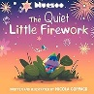  The Quiet Little Firework by Nicola Coppack | 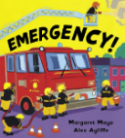  Emergency! By Margaret Mayo |  |  | 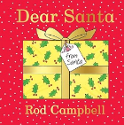  Dear Santa by Rod Rod Campbell
Autumn 2  Staying Safe | F1 Talk Through Stories | 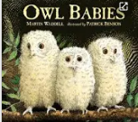  Owl babies by Martin Waddell |  | 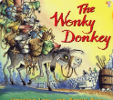  The wonky donkey by Jonathan Long |  | 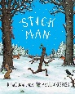  Stickman by Julia Donaldson
Autumn 2  Staying Safe | F2 Core Text | Crackle! Split! Poem by Marie Thom | 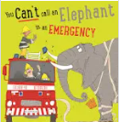  You can’t call an elephant in an emergency by Patricia Cleveland-Peck |  |  | 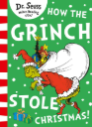  How the Grinch stole Christmas by Dr. Suess
Autumn 2  Staying Safe | F2 Talk through Stories | 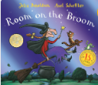  Room on the broom By Julia Donaldson |  | 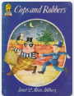  Cops and Robbers by Janet and Allan Ahlberg |  | 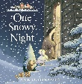  One Snowy Night by Nick Butterworth

Spring 1
 |  | Week 1 | Week 2 |  | Week 3 | Week 4 | Week 5 | Week 6
Spring 1  Our World | Topic Focus | Winter |  | Recycling |  |  | Looking after our environment
Spring 1  Our World | F1 Core Text | 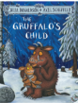  The Gruffalo’s Child by Julia Donaldson |  | 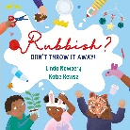  Rubbish! Don’t throw it away by Linda Newbery |  |  | 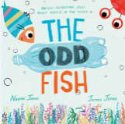  The odd fish by Naomi and James Jones
Spring 1  Our World | F1 Talk Through Stories | Settling in |  |  | 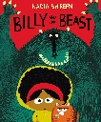  Billy and the beast by Nadia Shireen |  | 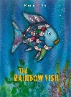  The rainbow fish by Marcus Pfisher
Spring 1  Our World | F2 Core Text | 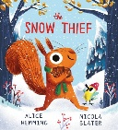  The Snow Thief by Alice Hemming |  | 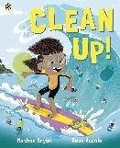  Clean Up by Nathan Bryon |  |  | 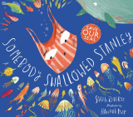  Somebody swallowed Stanley by Hannah Roberts.
Spring 1  Our World | F2 Talk through Stories | 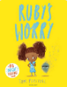  Ruby’s worry by Tom Percival |  |  | 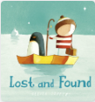  Lost and found by Oliver Jeffers |  | 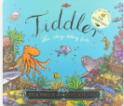  Tiddler by Julia Donaldson

Spring 2
 |  | Week 1 | Week 2 | Week 3 | Week 4 | Week 5
Spring 2  Space | Topic Focus | Planets |  | Astronauts |  | Festivals/celebrations Eid/ Easter
Spring 2  Space | F1 Core Text | 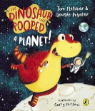  A dinosaur that pooped a planet by Tom Fletcher & Dougie Poytner |  | 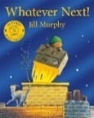  Whatever next by Jill Murphy |  | 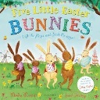  Five Little Bunnies by  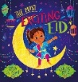  The most exciting Eid by Zeba Talkhani
Spring 2  Space | F1 Talk Through Stories | 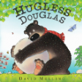  Hugless Doughless by David Melling |  | 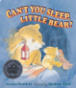  Can’t you sleep little bear by Martin Wadell
Spring 2  Space | F2 Core Text | 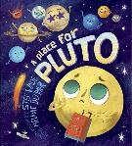  A place for Pluto by Stef Wade |  | 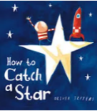  How to catch a star by Oliver Jeffers
Spring 2  Space | F2 Talk through Stories | 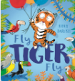  Fly tiger fly by Rikin Parekh |  | 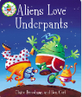  Aliens love underpants by Claire Freedman and Ben Cort

Summer 1
 |  | Week 1 | Week 2 | Week 3 | Week 4 | Week 5 | Week 6
Summer 1  Minibeasts | Topic Focus | Growing/Spring |  | Minibeasts |  | Life cycles
Summer 1  Minibeasts | F1 Core Text | 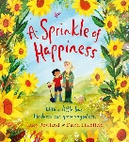  A sprinkle of happiness by Lucy Rowland |  | 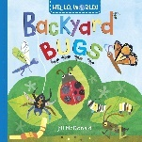  Betsy Buglove Saves the bees by Catherine Jacob |  | 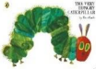  The very hungry caterpillar by Eric Carle
Summer 1  Minibeasts | F1 Talk Through Stories | Settling in |  | 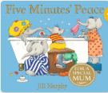  5 minutes peace by Jill Murphy |  | 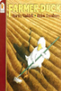  Farmer duck by Martin Wadell
Summer 1  Minibeasts | F2 Core Text | 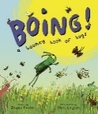  Boing by James Carter (poetry) |  | 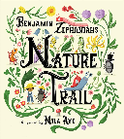  Nature Trail by Benjamin Zephaniah |  | 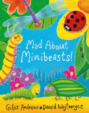  Mad about minibeasts by Giles Andreae
Summer 1  Minibeasts | F2 Talk through Stories | 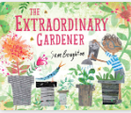  The extraordinary gardener by Sam Boughton |  | 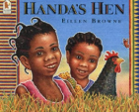  Handa’s Hen by Eireen Brown |  | 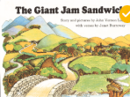  The Giant Jam Sandwich by John Vernon Lord and Janet Burroway

Summer 2
 |  | Week 1 | Week 2 | Week 3 | Week 4 | Week 5 | Week 6 | Week 7
Summer 2  Traditional Tales | Topic Focus | Traditional tales |  | Traditional tales |  | Transition/ Summer
Summer 2  Traditional Tales | F1 Core Text | 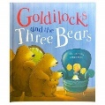  Goldilocks and the Three Bears |  | 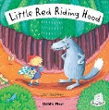  Little Red Riding Hood |  | 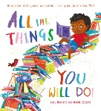  All the things you will do by Lucy Rowland
Summer 2  Traditional Tales | F1 Talk Through Stories | 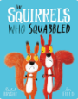  The squirrels who squabbled by Rachel Bright |  | 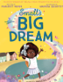  Smalls big dream by Manjeet Man |  | 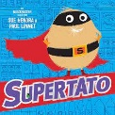  Supertato by Sue Hendra & Paul
Summer 2  Traditional Tales | F2 Core Text | 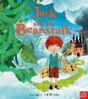  Jack and the beanstalk |  | 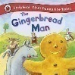  The Gingerbread Man |  | 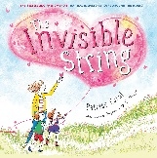  The invisible string by Patrice Karst
Summer 2  Traditional Tales | F2 Talk through Stories | 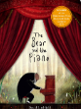  The bear and the Piano by David Litchfield |  | 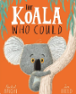  The Koala who could by Rachel Bright |  | 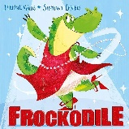  Frockodile by Jeanne Wais

