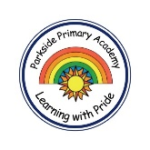
PARKSIDE PRIMARY ACADEMY - CURRICULUM OVERVIEW
 |  | Exploration 1 | Exploration 2 | Exploration 3 | Exploration 4 | Exploration 5 | Exploration 6
 | EYFS Cycle -2 – 2025-2026 | All About Me | Staying Safe | Our World | Space | Minibeasts | Traditional Tales
 | EYFS Cycle -2 – 2025-2026 | What is your superpower?  Through the core texts Our Classroom is a Family, Who Are You?, and Incredible Me, children are warmly welcomed into our school community. These stories support children in exploring their identity, recognising what makes them special, and beginning to develop important Personal, Social and Emotional Development (PSED) and Communication and Language skills as they get to know their peers.  Children will learn to identify key physical features, personal interests, and what makes them unique. They will also begin to recognise and talk about a range of emotions in themselves and others, fostering empathy and self-awareness.  As the term progresses, children will turn their attention to the world around them, discovering the seasonal changes that come with Autumn. They will explore the natural world and engage in learning around special celebrations, including Diwali and Halloween, broadening their understanding of cultural diversity and traditions.  Core Texts:  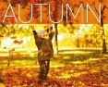  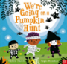  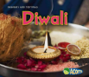  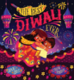  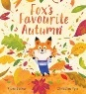  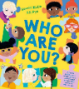  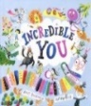  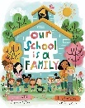  Talk through Stories:  Talk through stories and Poetry Time (Read Write Inc.) will also be used within our curriculum. The aim is to provide opportunities to develop children’s vocabulary, explore a wider range of texts and their understanding of plot, characters, actions and motives.  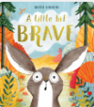  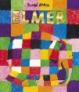  Some of the texts explore this half-term are:  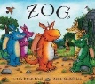  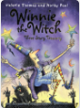  Why this, why now?  Many children will be beginning their school journey this term, providing a valuable opportunity to welcome them into our school community. They will begin to form friendships with their peers and share information about themselves to help build meaningful connections. As the season shifts from summer to autumn, children will also begin to observe and understand these natural changes. With our school situated next to the local park, they will have the chance to experience the signs of autumn first hand, deepening their connection to the local environment. | Who can you call in an emergency?  Through the core texts Emergency! and You Can’t Call an Elephant in an Emergency, children will explore the theme of people who help us. They will learn about key service workers in their community, the important roles they play in society, and how they help keep us safe and well. This topic also includes learning about dental hygiene and understanding the importance of brushing our teeth as part of staying healthy.  In addition to exploring emergency services, children will be introduced to seasonal celebrations such as Bonfire Night and Christmas. Core texts supporting this learning include the poem Crackle! Split!, The Quiet Little Firework, Dear Santa, and How the Grinch Stole Christmas. Through these stories and discussions, children will reflect on how they celebrate within their own community and learn about how people around the world observe similar events—recognising both differences and shared traditions.  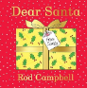  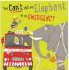  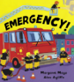  Core Texts:  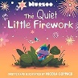  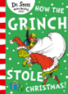  Talk through Stories:  Talk through stories and Poetry Time (Read Write Inc.) will also be used within our curium. Some of the texts explored this half-term are:  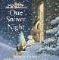  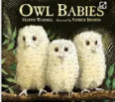  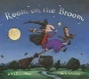  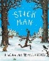  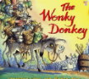  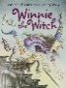  Why this, why now?  Learning about the people who help us allows children to make meaningful connections to individuals within their own community, building on their prior learning about themselves from Autumn 1. This term also includes several key celebrations. Some will be familiar and experienced by the children, while others offer opportunities to broaden their cultural awareness and develop cultural capital within the setting.  As part of this learning, children will also begin to understand the importance of keeping themselves safe during celebrations and special events, both in school and in the wider community. | How is our world changing?  Children will begin to develop a deeper understanding of the world around them by exploring what they can see, hear, smell, touch, and feel. Through sensory experiences and discussion, they will begin to build a foundation of knowledge about their environment. Children will also begin to make connections between local and global events, learning how their actions can positively impact their community and the wider world.  As they explore seasonal changes, children will observe and discuss patterns in weather and the natural world. Using the core texts The Gruffalo’s Child and The Snow Thief, they will investigate the features of Winter and how it affects the environment.  This learning will lead into an exploration of caring for the planet, using engaging core texts such as Clean Up!, Rubbish! Don’t Throw It Away, The Odd Fish, and Somebody Swallowed Stanley. These stories will help children understand the importance of protecting our environment and inspire them to take small but meaningful actions to make the world a better place.  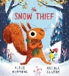  Core Texts:  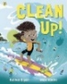  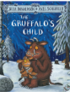  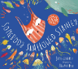  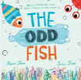  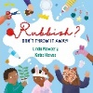  Talk through Stories:  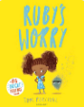  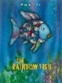  Talk through stories and Poetry Time (Read Write Inc.) will also be used within our curium. Some of the texts explored this half-term are:  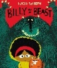  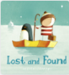  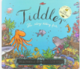  Why this, why now?  Children will have observed the seasonal changes since starting school, moving from summer to autumn and now into winter. They will begin to discuss these changes and develop a broader understanding of the four seasons. This learning builds on their knowledge of themselves from Autumn 1 and the people in their community from Autumn 2, progressing now to a focus on the environment around them.  There is also a natural link from learning how to keep themselves safe in Autumn 2 to understanding how they can help protect and care for the world they live in. | How do you catch a star?  Children will explore the world above them by learning about the sun, moon, and stars. They will begin to make connections to the planet they live on, identifying key features of Earth and recognising its place within the solar system. Through engaging core texts such as How to Catch a Star, Whatever Next!, The Dinosaur That Pooped a Planet, and A Place for Pluto, children will be introduced to the planets and encouraged to explore similarities and differences among them.  This topic will also spark imagination, as children embark on creative journeys into space, thinking and talking about what might exist in our wider universe.  Alongside this, children will learn about the festivals of Easter and Eid—what they mean, how they are celebrated, and the values they represent. These celebrations offer an opportunity to explore different cultures and beliefs, fostering respect, curiosity, and a sense of global community.  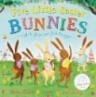  Core Texts:  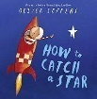  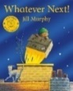  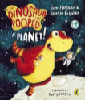  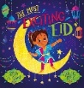  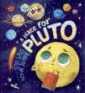  Talk through Stories:  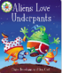  Talk through stories and Poetry Time (Read Write Inc.) will also be used within our curium. Some of the texts explored this half-term are:  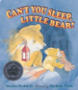  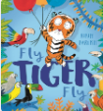  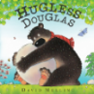  Why this, why now?  This topic lays the foundational knowledge of space, which is further developed in Year 2 and Year 5. It builds on the learning from Spring 1, where children explored the world around them, by extending their curiosity upwards to the world above them—the sun, moon, stars, and planets. This progression helps deepen their understanding of Earth’s place within the wider universe and encourages them to think critically about space, science, and our environment. | I’m a minibeast get me out of here!  Through the core texts The Very Hungry Caterpillar, A Sprinkle of Happiness, Betsy Buglove Saves the Bees, Boing, Nature Trail, and Mad About Minibeasts, children will explore a wide range of minibeasts, their habitats, and their life cycles. They will begin to develop an understanding of the importance of respecting and caring for the natural environment and all living things.  Alongside their learning about minibeasts, children will also investigate plant life cycles. They will have the opportunity to grow and care for their own plants, developing a sense of responsibility and wonder for living things. Through close observation of plants and animals, children will use their senses to draw what they see, hear, and smell—encouraging curiosity, attention to detail, and a deepened connection to the natural world around them.  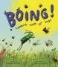  Core Texts:  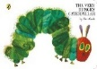  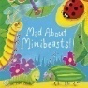  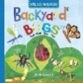  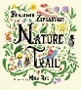  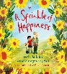  Talk through Stories:  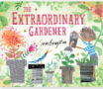  Talk through stories and Poetry Time (Read Write Inc.) will also be used within our curium. Some of the texts explored this half-term are:  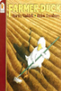  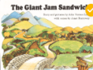  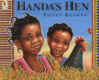  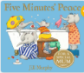  Why this, why now?  This topic provides a foundation for learning that continues through Years 1, 2, and 3. Children will explore a variety of animals and plants, focusing on their life cycles, which will be studied in greater depth in later years. Scheduled for Summer 1, this topic takes advantage of the season’s natural conditions that promote growth, allowing children to actively engage in growing their own plants. This hands-on experience helps deepen their understanding of life cycles and the environment. | Who blew the house down?  Children will use the anchor texts Goldilocks and the Three Bears, Jack and the Beanstalk, Little Red Riding Hood, and The Gingerbread Man to explore the rich world of traditional tales. They will learn to retell key parts of each story, develop expressive arts skills through role-play and drama, and begin to create their own storylines. Children will explore characters, settings, and plots, making connections to their own experiences and understanding of the world.  In the final weeks of the term, children will begin to explore the concept of transition—whether moving from Nursery to Reception or from Reception to Year 1. They will have opportunities to visit their new classrooms, meet their new teachers, and talk about the changes ahead, helping to build confidence and excitement for the next stage of their learning journey.  Core Texts:  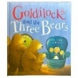  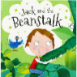  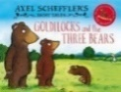  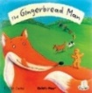  Talk through Stories:  Talk through stories and Poetry Time (Read Write Inc.) will also be used within our curium. Some of the texts explored this half-term are:  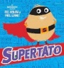  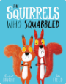  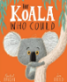  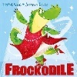  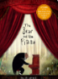  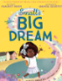  Why this, why now?  This topic introduces children to literacy skills through stories and storytelling. They will begin to explore how stories are structured and start developing ‘why’ questions to deepen their understanding and curiosity. This early engagement provides a strong foundation for using stories in writing and helps children recognize the different elements that make up a story. This learning is further built upon in Autumn 1 of Year 1, where children continue exploring traditional tales, such as The Three Little Pigs.
 |  | All About Me | Celebrations | Seasons and Weather | Traditional Tales | Transport, Holiday and Journeys | In the Garden
 | EYFS Cycle 1 2024-2025 | What is your superpower?  Through the core texts Our Classroom is a Family, All Are Welcome, Incredible You, and This Is Me, children are warmly welcomed into our school community. These stories help children explore who they are, what makes them special, and begin to develop key Personal, Social and Emotional Development (PSED) and Communication and Language skills as they get to know their peers. Children will start to recognise their own physical features, interests, and unique qualities. They will also begin to identify and discuss emotions in themselves and others.  As the term progresses, our focus will shift to non-fiction core texts such as Days Out in Autumn and Autumn. Through these, children will explore the changing seasons and all that autumn has to offer. This will lay a foundation for understanding seasonal change, which will be further developed in Spring 1.  Finally, our core texts Shubh Diwali and We’re Going on a Pumpkin Hunt will introduce children to different religions, celebrations, and festivals, broadening their cultural awareness.  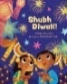  Core Texts:  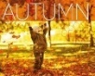  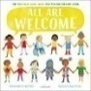  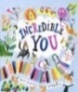  Talk through Stories:  Talk through stories and Poetry Time (Read Write Inc.) will also be used within our curriculum. The aim is to provide opportunities to develop children’s vocabulary, explore a wider range of texts and their understanding of plot, characters, actions and motives.  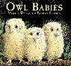  Some of the texts explore this half-term are:  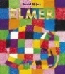  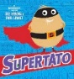  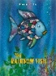  Why this, why now?  Many children will be starting their school journey this term, providing a valuable opportunity to welcome them into our school community. They will begin to form friendships with their peers and share information about themselves, helping to build meaningful connections. As the season changes from summer to autumn, children will develop their understanding of these natural changes and experience them firsthand in our local environment, as our school is situated next to the local park. | What do you celebrate?  Through our core texts Pumpkin Soup, How Many Sleeps Till My Birthday?, Funnybones, Uncle Bobby’s Wedding, The Dinosaur Who Pooped a Reindeer, and The Grinch Who Stole Christmas, children will begin to explore a variety of celebrations and events. These include Halloween, birthdays, weddings, and Christmas.  Children will examine how these events are celebrated in their local community and learn about how people around the world observe similar occasions, making connections by identifying both similarities and differences. They will have opportunities to role-play and act out special events, linking these experiences to their own lives and those of others.  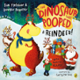  Core Texts:  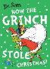  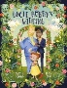  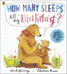  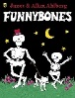  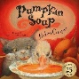  Talk through Stories:  Talk through stories and Poetry Time (Read Write Inc.) will also be used within our curium. Some of the texts explored this half-term are:  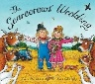  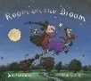  Why this, why now?  Building on the learning from Autumn 1, children will continue to explore different celebrations and special events, as several important occasions take place during this time of year. Some celebrations will be ones the children personally experience, while others will introduce them to new cultural traditions, helping to broaden their cultural capital within the setting. Children will also have the opportunity to participate in a Christmas performance and other school celebration events.  This early exposure provides a strong foundation for future learning about celebrations and historical events throughout the school years—for example, studying Guy Fawkes in Year 1. | What s happening to the world around us?  Through the core texts Seasons, Little Cloud, The Season, and Meet the Weather, children will explore seasonal changes and weather throughout this half-term. They will develop their understanding of the changing world around them using their senses. Children will investigate the effects of winter on the environment and learn how people adapt to colder weather through appropriate clothing and activities. They will also explore how different animals adjust to seasonal changes during winter.  Children will have opportunities to compare the seasons they have learned about so far and make predictions about what might happen in other seasons. Various weather types will be examined, along with discussions on how to stay safe in different weather conditions.  Alongside learning about weather, children will also discover Lunar New Year through the core texts The Great Race and I Love Chinese New Year. They will explore how this festival is celebrated around the world and compare it to other celebrations they have previously learned about.  Core Texts:  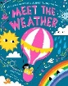  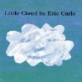  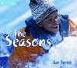  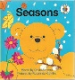  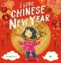  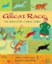  Talk through Stories:  Talk through stories and Poetry Time (Read Write Inc.) will also be used within our curium. Some of the texts explored this half-term are:  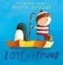  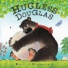  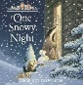  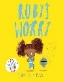  Why this, why now?  Children will have experienced a variety of weather conditions during their time at school and observed the visual changes as the seasons progress from summer to autumn and now winter. They will be able to discuss these changes and begin to develop an understanding of all the seasons, as well as how weather and seasons are interconnected. This builds on the learning from Autumn 1 about autumn and provides a strong foundation for continued exploration of seasonal changes and their effects in Year 1, including topics such as animal survival in Summer 1. | Who blew the house down?  Children will use the anchor texts Goldilocks and the Three Bears, Jack and the Beanstalk, Little Red Riding Hood, and The Gingerbread Man to explore traditional tales. They will learn to recite key parts of the stories, develop their expressive arts skills by acting out scenes, and create their own storylines. Children will examine key characters, plots, and settings, making connections to their own lives.  Alongside this, children will explore Eid through the core texts The Most Exciting Eid and In My Mosque, as well as Easter through The Rhyming Rabbit and Easter Story. They will learn how these events are celebrated around the world and compare them to celebrations previously studied.  Core Texts:  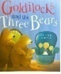  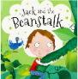  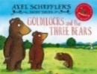  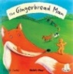  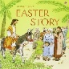  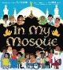  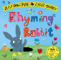  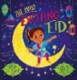  Talk through Stories:  Talk through stories and Poetry Time (Read Write Inc.) will also be used within our curium. Some of the texts explored this half-term are:  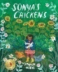  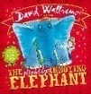  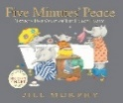  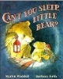  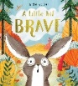  Why this, why now?  Children will begin to develop literacy skills through stories and storytelling. They will explore how stories are structured and start to ask ‘why’ questions to deepen their understanding. This foundation supports their later use of stories in writing and helps them recognize the different elements that make up a story. This learning continues in Year 1, where children study the traditional tale The Three Little Pigs. | Where and how can you travel?  Through the core texts The Train Ride, Mr Grumpy’s Motor Car, Captain Finn and the Pirate Dinosaurs, and Martha Maps It Out, children will explore different modes of transport and their primary uses. They will discuss various places they could visit, consider how they would get there, and think about what activities they might do. Children will have opportunities to reflect on their own experiences and connect these to their learning.  In addition, children will explore a range of maps, learning what they show and how to read them. They will embark on a ‘journey’ around the school, developing their mapping skills by drawing where they went and what they saw along the way.  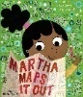  Core Texts:  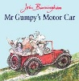  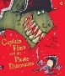  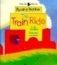  Talk through Stories:  Talk through stories and Poetry Time (Read Write Inc.) will also be used within our curium. Some of the texts explored this half-term are:  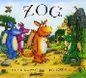  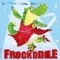  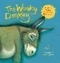  Why this, why now?  Children will explore a variety of transport methods, learning how people use different types of vehicles to move around locally and globally. They will discuss the purposes of transport—such as traveling for work, school, or holidays—and begin to understand the importance of transport in daily life.  By connecting these ideas to their own personal experiences, children will build a meaningful foundation for later learning. In Year 2, they will study transport during the Victorian era, comparing it to modern-day methods. This will help them identify key similarities and differences, deepening their understanding of how technology and society have changed over time.  Throughout this topic, children will develop vocabulary related to transport, practice map skills by exploring routes, and engage in imaginative play that encourages communication and problem-solving. | What can you find in the garden?  Through the core texts The Tiny Seed, We’re Going on a Bear Hunt, Mr Wolf and the Enormous Turnip, and Nature Trail, children will engage with the outdoors to explore various plants and animals. They will learn how to grow plants and understand what plants need to survive. Children will also investigate different animals, discovering how to care for them and develop respect for nature.  This topic offers many opportunities for observational drawings and meaningful discussions. Additionally, children will develop their gross motor skills by building dens outdoors and experimenting with different materials to determine which are most suitable and why.  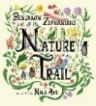  Core Texts:  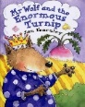  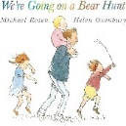  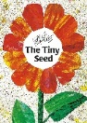  Talk through Stories:  Talk through stories and Poetry Time (Read Write Inc.) will also be used within our curium. Some of the texts explored this half-term are:  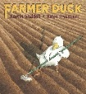  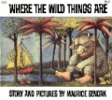  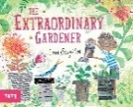  Why this, why now?  This topic provides a foundational understanding that is built upon in Years 1, 2, and 3. Children will explore a variety of animals and plants, focusing on their life cycles—a concept that is examined in greater depth in subsequent years. Covering this topic in the summer term allows children to actively engage in growing their own plants, taking advantage of the season’s ideal conditions for new growth and hands-on learning.  In addition, children will explore den building and investigate different materials, linking this practical experience to future learning about materials and their uses in Year 1. These activities encourage curiosity, problem-solving, and an understanding of the natural world and the properties of materials.

